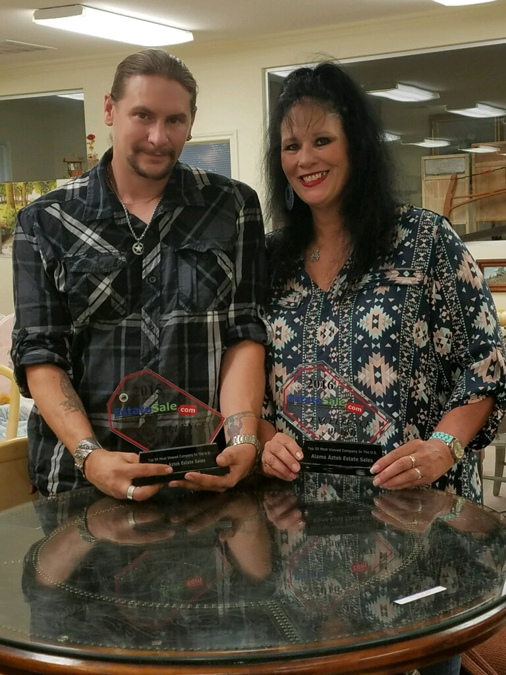

**MATT KILGORE BETH MILES**

**ESTATE SALE SPECIALISTS**

**OWNERS**

**ALAMO AZTEK ESTATE SALES**

**CREDENTIALS & QUALIFICATIONS**

**TRAINED BY JUDY HART, PANELIST, ANTIQUES ROADSHOW**

**CERTIFIED BY THE NATIONAL SOCIETY OF ANTIQUES AND COLLECTIBLES**

**OVER 1000 SUCCESSFUL ESTATE SALES COMPLETED IN CAREER**

**EXPERT SPEAKER ESTATE SALES CONFERENCE 2008**

**EXPERT SPEAKER 10 20 30 DEPRESSION ERA GLASS SOCIETY 2007**

**INVITATION BOARD MEMBER NATIONAL DIRECTORS OF ESTATE SALES**

**AWARD 2015 MEGA ESTATE SALES TOP 50 NATIONAL COMPANY**

**AWARD 2016 MEGA ESTATE SALES TOP 50 NATIONAL COMPANY**

**AWARD 2015 TOP 5 TEXAS VIEWED ESTATE SALE COMPANIES**

**AWARD 2017 TOP 5 TEXAS VIEWED ESTATE SALE COMPANIES**

**EXPERT IN FURNITURE, WEAPONS, JEWELRY, MUSICAL INSTRUMENTS, ASIAN, NATIVE AMERICAN, GLASS**